HARTA EXTRAVILAN CLUJ-NAPOCA

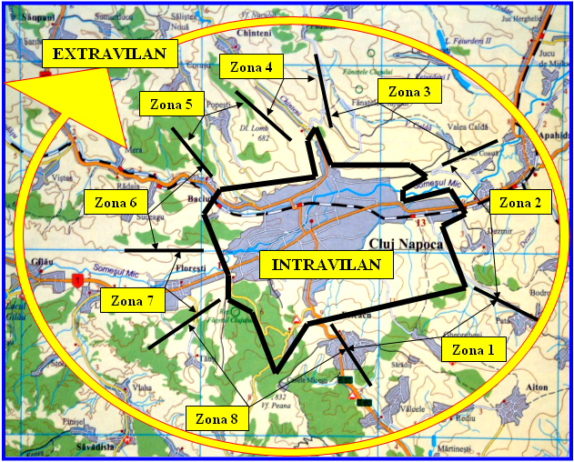 | 